Template for the 16th World Conference on Thermophotovoltaic Generation of Electricity (Title in 18-point Times New Roman font)
List authors on this line using 12-point Times New Roman font – use a second line if necessary

Authors' affiliation(s) listed here using 12-point Times New Roman font – use a second line if necessary

Work in Progress

Abstract — Use 9-point Times New Roman Bold font for the abstract. Set your line spacing to be 10 points rather than a single space. Indent the first line by 0.125 inches and type the word "Abstract" in 9-point Times New Roman Bold Italic. This should be followed by two spaces, a long dash (option / shift / minus), two spaces, and then the first word of your abstract (as shown above). Please try to keep the length of your abstract to 600 words or less. Please insert a figure below illustrating the main result of your work in progress.

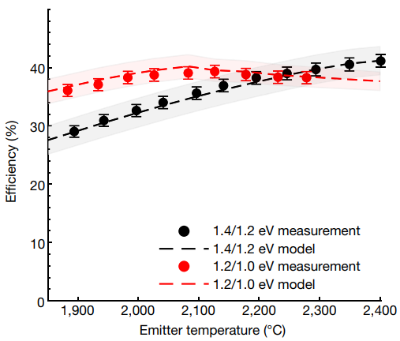

Fig. 1. Example of readable plot using different colors and line styles for clarity.

References
[1] A. LaPotin et al., “Thermophotovoltaic efficiency of 40%”, Nature, vol. 604, n.o 7905, Art. n.o 7905, 2022, doi: 10.1038/s41586-022-04473-y.
[2] M. Steiner et al., “Record efficiency InGaAs thermophotovoltaic cells for energy storage applications”, NREL, Golden, CO (United States), NREL/PR-5900-82094, 2022.
[3] T. Bauer, Thermophotovoltaics: Basic Principles and Critical Aspects of System Design. Green Energy and Technology. Berlin, Heidelberg: Springer, 2011. doi: 10.1007/978-3-642-19965-3.

