Template for the 16th World Conference on Thermophotovoltaic Generation of Electricity (Title in 18-point Times New Roman font)
List authors on this line using 12-point Times New Roman font – use a second line if necessary

Authors' affiliation(s) listed here using 12-point Times New Roman font – use a second line if necessary

Abstract — Use 9-point Times New Roman Bold font for the abstract. Set your line spacing to be 10 points rather than a single space. Indent the first line by 0.125 inches and type the word "Abstract" in 9-point Times New Roman Bold Italic. This should be followed by two spaces, a long dash (option / shift / minus), two spaces, and then the first word of your abstract (as shown above). Please try to keep the length of your abstract to 200 words or less.

I. Introduction
This template has been formatted in the manner in which you should prepare your final manuscript; you may use this Word document as a template. Please use this as an example.
A contributor should remember that the manuscripts must be submitted electronically to the dedicated website. Manuscripts must be submitted in PDF format. Should you have any difficulty with the electronic submission process, please contact us.
Please make sure that your document is no more than two pages in length, and includes these main points:

- Full title of the paper
- Full author list and affiliation
- Introduction or background of the paper topic
- Main experimental and/or theoretical results
- Analysis of the results and clear exposition of the main findings
- Discussion of the significance of the work for the field
- Summary of the work
- References

II. Detailed Text Formatting
Use a two-column format. All paragraphs of text, including the abstract, figure captions, and references, should be justified at the left and the right edges.
For the Title, use 18-point Times (Roman) font. Its paragraph description should be set so that the line spacing is single with 6-point spacing before and 6-point spacing after (Format --> Paragraph --> Indents and Spacing). The font description for the Authors' List and Authors' Affiliation(s) should be 12-point Times. The paragraph descriptions should be set so that the line spacing is single with 6-point spacings before and after. Use an additional line spacing of 12 points before the beginning of the double column section, as shown above.
Using 8.5 x 11-inch paper, the top margin is 0.75 inch, the bottom margin is 1 inch, and the left and right margins are
0.625 inch. Except for the Title, Authors and Affiliations, use a double-column format. The column width is 3.5 inches and the column spacing is 0.25 inch.
Each major section begins with a Heading in 10-point Times font centered within the column and numbered using Roman numerals (except for Acknowledgements and References), followed by a period, a single space, and the title using an initial capital letter for each word. The remaining letters are in small capitals. The paragraph description of the section heading line should be set for 18 points before, 6 points after, and the line spacing should be set to exactly 12 points.
For the body of your paper, use 10-point Times font and set your line spacing at "exactly 12 points" with 0 points before and after. Indent each paragraph by 0.125 inches.
Further details are provided in the remainder of this paper for specific situations.
- Major subsections
As shown, denote subsections with left justified 10-point Times Italic. Order them with capitalized alphabetic characters (A, B,...). Follow the letter designation with a period, a single space, and then the subsection title capitalizing the first letter of each word. The paragraph description of the subsection heading is set to "exactly 12-point" line spacing with 6 points before and after.
- Equations
Equations should be centered in the column and numbered sequentially. Place the equation number to the right of the equation within a parenthesis, with right justification within its column. An example would be:

$η_{TPV}=\frac{P_{el}}{P_{abs}}=\frac{P_{el}}{P_{el}+Q}$ (1)
Make sure that any subscripts in your equations are legible and are not too small to read! When referring to an equation, use the number within parentheses. For example, you would usually refer to the first equation as (1) rather than equation (1). If possible, use the Symbol font for all special characters, or better yet, use Equation Editor™ or MathType™.
TABLE I
Summary of Typographical Settings
 | Font Specifics |  |  | Paragraph Description
Section | (Times Roman unless specified) |  |  | spacing (in points) |  |  | alignment | indent
 | style | size | special | line | before | after |  | (in inches)
Title | plain | 18 | none | single | 6 | 6 | centered | none
Author List | plain | 12 | none | single | 6 | 6 | centered | none
Affiliations | plain | 12 | none | single | 6 | 6 | centered | none
Abstract | bold | 9 | none | exactly 10 | 0 | 0 | justified | 0.125 1st line

III. Figures AND Tables
The use of color in figures and photos is recommended. Please consider the use of different line styles (dashes, dots, etc.) in plots to ensure clarity.
Figures and tables should be positioned within the text. Illustrations and graphics may be one- or two-columns wide and should include captions or titles, as in the examples below.
Figures should utilize as much of the column width as possible in order to maximize legibility. When referring to a figure, use the abbreviation Fig. followed by its number. Place figure captions directly below each figure. Use 9-point Times with the paragraph spacing set at "exactly 10 points". Note that figure captions are always (left and right) justified, rather than centered, even if they are less than a single full line in length. See the captions for Fig. 1.
Within Microsoft Word, there are several options for placing figures within your paper. Often the easiest is to insert them between existing paragraphs, allowing the figures to remain in that relative position. The paragraph description where the figure is inserted must be set to "single" spacing rather than "exactly 12 points" in order to allow the line to autoscale in height to display the entire figure. Some disadvantages of this approach are that you don't have total flexibility in placing figures, and that the figures will move as text is inserted or deleted in any part of the document before the figure.
Table I also serves as an illustration of one of the rare instances when the double-column format requirement can be violated. When possible, use a table editor or tabs to create tables.

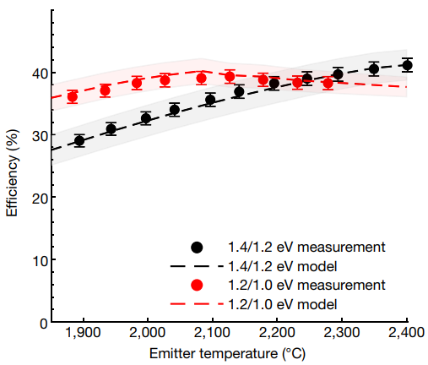

Fig. 1. Example of readable plot using different colors and line styles for clarity.

IV. Citing Previous Work
When referencing a journal article [1], a conference article [2] or a book [3], place the reference numbers within square brackets. To simultaneously cite these references [1]-[3] use the format just demonstrated. The reference list is the last section and references are listed in the order cited. Use 9-point Times. The paragraph description is set for a line spacing of exactly 10 points with 0-point spacing before and after. A 0.25 inch hanging indention should be specified.

References
[1] A. LaPotin et al., “Thermophotovoltaic efficiency of 40%”, Nature, vol. 604, n.o 7905, Art. n.o 7905, 2022, doi: 10.1038/s41586-022-04473-y.
[2] M. Steiner et al., “Record efficiency InGaAs thermophotovoltaic cells for energy storage applications”, NREL, Golden, CO (United States), NREL/PR-5900-82094, 2022.
[3] T. Bauer, Thermophotovoltaics: Basic Principles and Critical Aspects of System Design. Green Energy and Technology. Berlin, Heidelberg: Springer, 2011. doi: 10.1007/978-3-642-19965-3.

